A

**PROJECT**

On

**Online Video Steaming Website**

Submitted

By

**ASIF ERFAN KHAN**

(BSC. COMPUTER SCIENCE)

SEM-VI

Under the Guidance of

Dr. Prabha Kadam

Department of Computer Science



**DEPARTMENT OF COMPUTER SCIENCE**

**DADAR, MUMBAI**

**APRIL 2022**

**INDEX**

|  |  |
| --- | --- |
| SR.NO | TITLE |
| 1 | TITLE OF THE PROJECT |
| 2 | INTRODUCTION |
| 3 | EXISTING SYSTEM |
| 4 | PROPOSED SYSTEM |
| 5 | ADVANTAGES |
| 6 | KEY FEATURES OF THE PROJECT |
| 7 | SYSTEM REQUIREMENTS |
| 8 | ENTITY RELATIONSHIP DIAGRAM |
| 9 | EVENT TABLE |
| 10 | FLOWCHART |
| 11 | CLASS DIAGRAM |
| 12 | USE CASE DIAGRAM |
| 13 | ACTIVITY DIAGRAM |
| 14 | SEQUENCE DIAGRAM |
| 15 | CODES |
| 16 | OUTPUT |

**Title of the project**

Online Video Streaming Website.

**Introduction**

*As all of us know that online video streaming websites are becoming so much popular all around the world. This kind of website provide a sort of entertainment for the user. Netflix is the best example for Online Video Streaming website. On Netflix a user can watch video after registering. So, the same idea was implemented here where users can watch movies and TV shows for free after registering.*

**Existing System**

*The purpose of this project is to develop and implement an Online Video Streaming Website for online viewing of Movies and TV Shows, where a user can watch media online without wasting time to download each media which uses storage space on their machine. The current system has many flaws like Geographic Limitations, High Speed Internet Requirements, Outdated Library and more.*

**Proposed System**

*Online Movie Streaming project is related to same concept as Netflix or Amazon Prime Video where users can watch movies and TV shows online but, in our system, User can watch media for free with just one time registration without the restriction of Geographic Limitations, we keep our libraries updated to get you the latest and the best content.*

**Advantages**

* *Watch for free.*
* *No Geographical Limitations.*
* *It’s Ad free.*
* *Updated content.*
* *High Quality video playback.*
* *Device Compatibility.*
* *Simple and easy to use*

**Disadvantages**

* *Slow internet can cause lot of buffering (Client Side).*
* *New content is not available right away.*

**Key Features**

* *Seamless streaming experience.*
* *Huge content library.*

**System requirements**

|  |  |  |  |
| --- | --- | --- | --- |
|  | **Windows requirements** | **Mac requirements** | **Linux requirements** |
| **Operating system** | *Windows 8 or later* | *macOS Sierra 10.12 or later* | *64-bit*  *Ubuntu 14.04+,*  *Debian 8+,*  *openSUSE 13.3+, or*  *Fedora Linux 24+* |
| **Processor** | *Intel Pentium 4 or later* | *Intel* | *Intel Pentium 4 or later* |
| **Memory** | *2 GB minimum, 4 GB recommended* |
| **Screen resolution** | *1280x1024 or larger* |
| **Application window size** | *1024x680 or larger* |
| **Internet connection** | *Required* |

**Programming languages used**

* *Operating System: Any*
* *Server Technology: PHP/XAMPP*
* *Database: MySQL*
* *Markup Language: HTML*
* *Scripting Language: CSS/JavaScript*

**Entity Relationship Diagram**

*Entity Relationship Diagram is a graphical model of the data needed by a system, including things about which information is stored and the relationship among them, produced in structured analysis and information engineering. On the Entity Relationship Diagram. Rectangles represent data entities and the Lines connecting the rectangles show the relationship among data entities.*

*ERD Notations:*

*Rectangle:*

*Represents Data Entity.*

*Circle:*

*Represents Connection.*

*Diamond:*

*Represents the process*

*Or*

*Relation between two entities.*

*Line:*

*Connects two entities, also helps in showing relationship.*

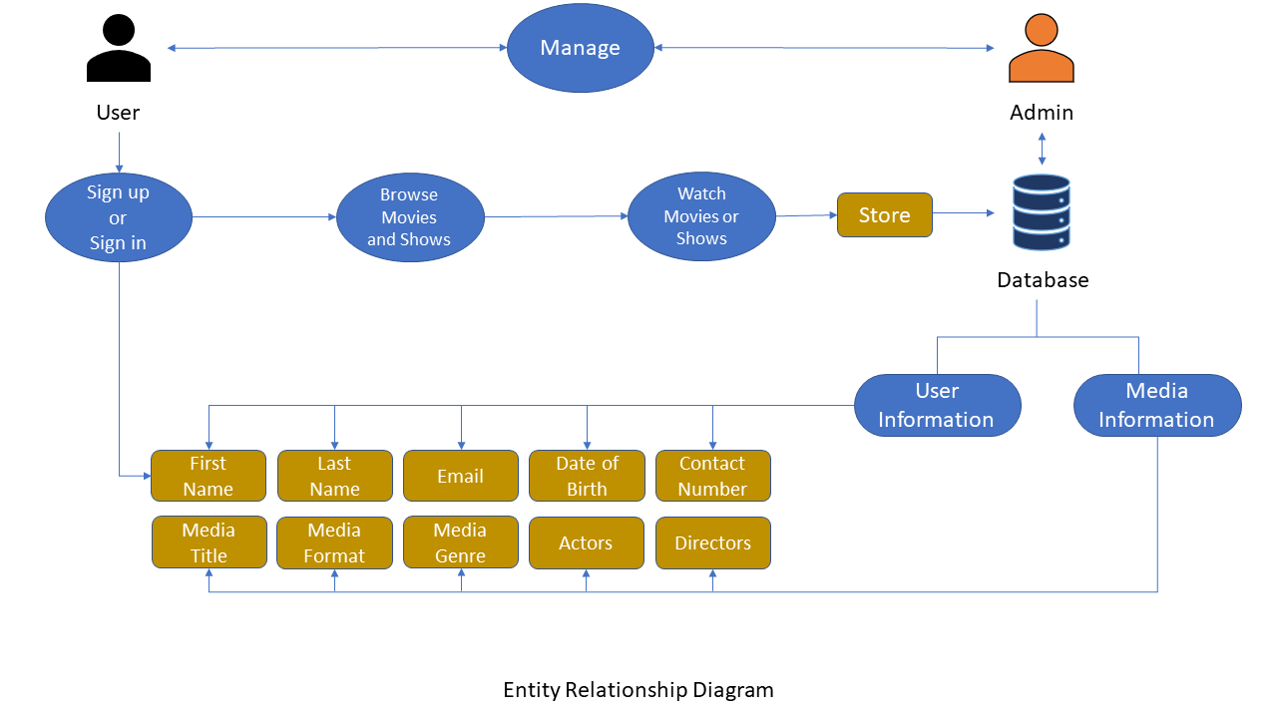

**Event Table**

*The event table is a table of data that is typically written to the logfile for each scenario and also appears in the Analysis window. The event table contains timing information about specific events that occur during the scenario.*

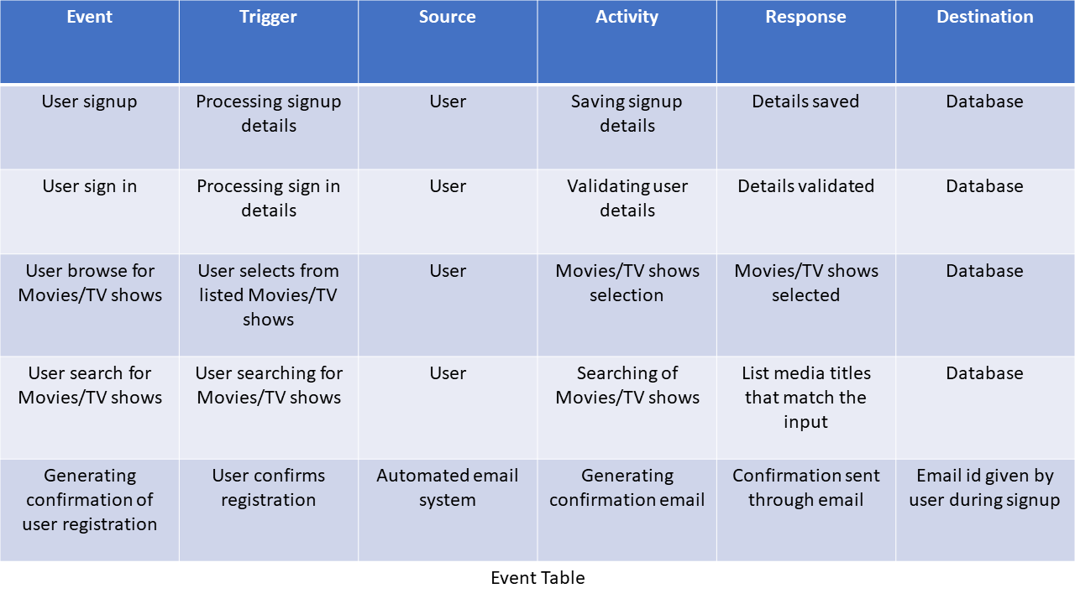

**Flow Chart**

*A flowchart is a type of diagram that represents a workflow or process.*

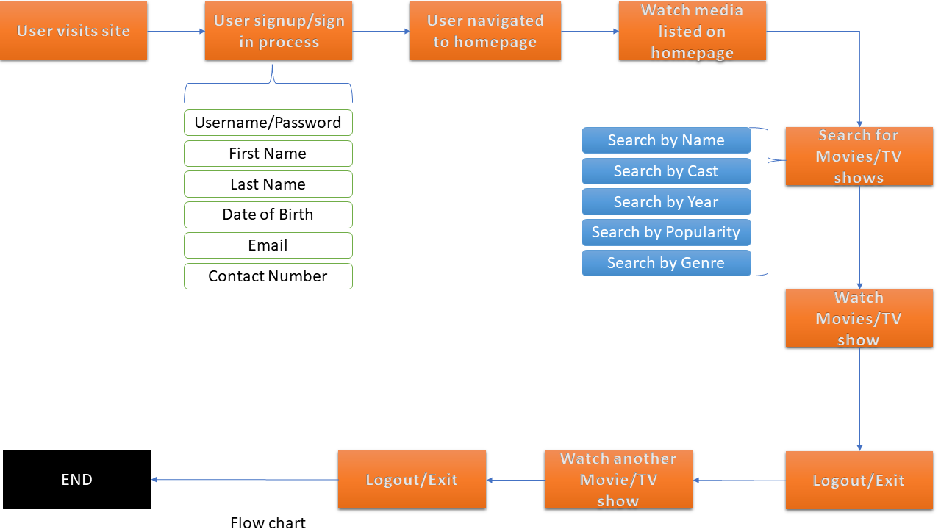

**Class Diagram**

*A class diagram in the Unified Modelling Language is a type of static structure diagram that describes the structure of a system by showing the system’s classes.*

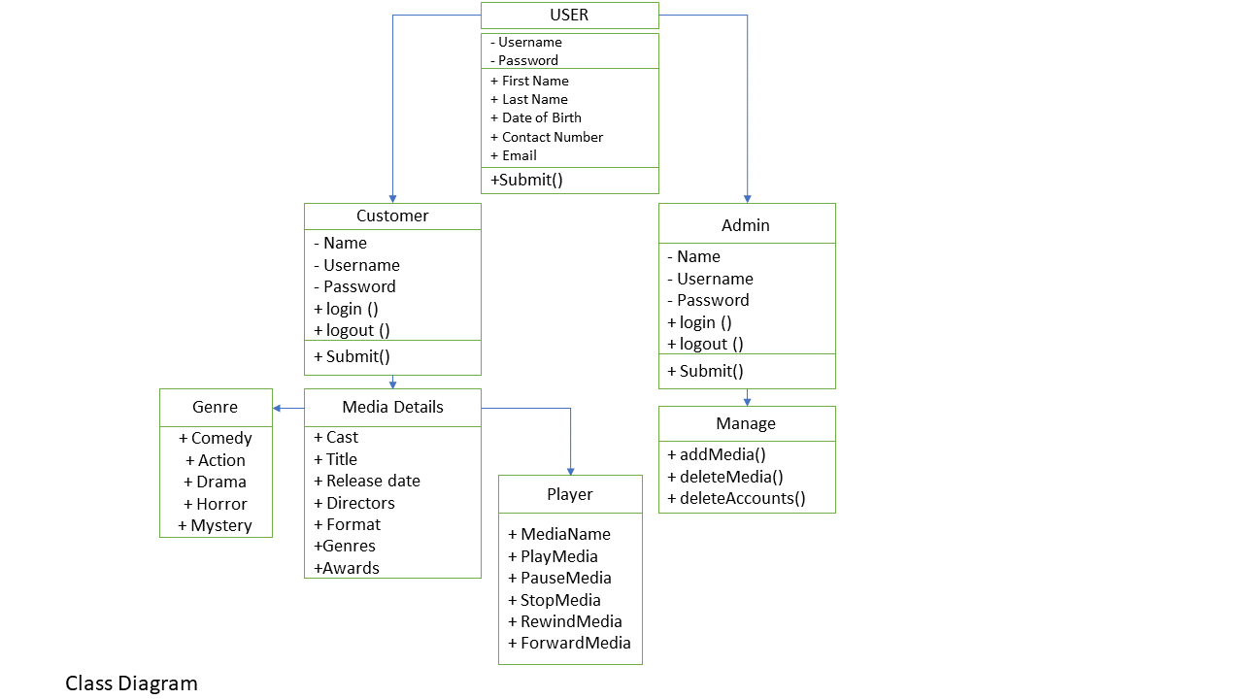

**Use Case Diagram**

*A use case diagram is a graphical depiction of a user’s possible interactions with a system.*

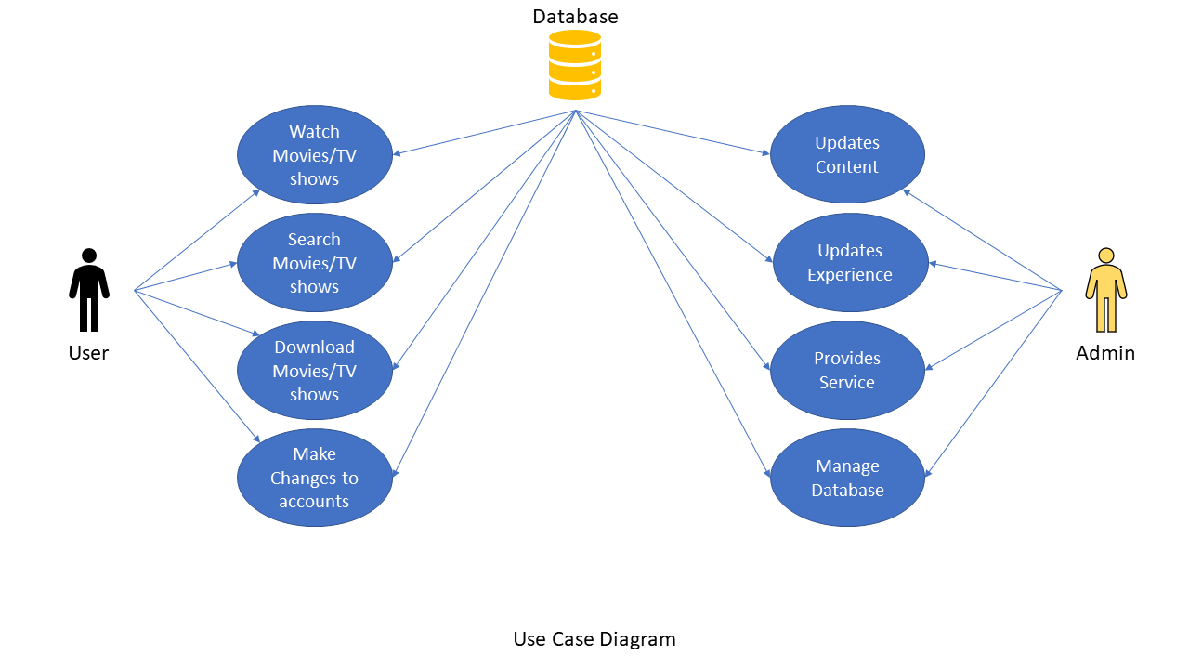

**Activity Diagram**

*Activity diagrams are graphical representations of workflows of stepwise activities and actions with support for choice. Iteration and concurrency.*

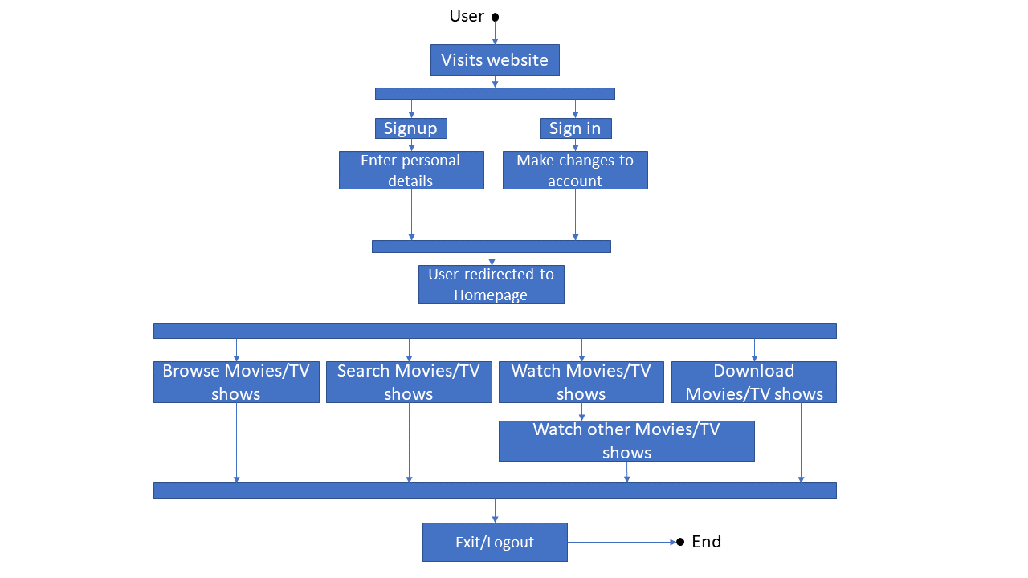

**Codes:**

<!DOCTYPE html>

<html lang="en">

<head>

<meta charset="UTF-8" />

<meta http-equiv="X-UA-Compatible" content="IE=edge" />

<meta name="viewport" content="width=device-width, initial-scale=1.0" />

<title>Video Streaming</title>

<link rel="stylesheet" href="css/bootstrap.min.css" />

<link rel="stylesheet" href="https://stackpath.bootstrapcdn.com/font-awesome/4.7.0/css/font-awesome.min.css" />

<link rel="stylesheet" href="css/slick.css" />

<link rel="stylesheet" href="css/slick-theme.css" />

<link rel="stylesheet" href="css/owl.carousel.min.css" />

<link rel="stylesheet" href="css/animate.min.css" />

<link rel="stylesheet" href="css/magnific-popup.css" />

<link rel="stylesheet" href="css/select2.min.css" />

<link rel="stylesheet" href="css/select2-bootstrap4.min.css" />

<link rel="stylesheet" href="css/slick-animation.css" />

<link rel="stylesheet" href="style.css" />

<style>

html {

scroll-behavior: smooth;

}

</style>

</head>

<body>

<header id="main-header">

<div class="main-header">

<div class="container-fluid">

<div class="row">

<div class="col-sm-12">

<nav class="navbar navbar-expand-lg navbar-light p-0">

<a href="#" class="navbar-toggler c-toggler" data-toggle="collapse" data-target="#navbarSupportedContent"

aria-controls="navbarSupportedContent" aria-expanded="false" aria-label="Toggle navigation">

<div class="navbar-toggler-icon" data-toggle="collapse">

<span class="navbar-menu-icon navbar-menu-icon--top"></span>

<span class="navbar-menu-icon navbar-menu-icon--middle"></span>

<span class="navbar-menu-icon navbar-menu-icon--bottom"></span>

</div>

</a>

<a href="index.html" class="navbar-brand">

<img src="images/logo.png" class="img-fluid logo" alt="" />

</a>

<div class="collapse navbar-collapse" id="navbarSupportedContent">

<div class="menu-main-menu-container">

<ul id="top-menu" class="navbar-nav ml-auto">

<li class="menu-item"><a href="#">Home</a></li>

<li class="menu-item"><a href="/Movies.html">Movies</a></li>

<li class="menu-item"><a href="/TVShows.html">Shows</a></li>

<li class="menu-item">

<a href="#">Contact Us</a>

<ul class="sub-menu">

<li class="menu-item"><a href="https://about.netflix.com/en/about-us">About Us</a></li>

<li class="menu-item"><a href="https://help.netflix.com/en/contactus">Contact</a></li>

<li class="menu-item"><a href="https://help.netflix.com/en/node/412">FAQ</a></li>

<li class="menu-item">

<a href="https://help.netflix.com/legal/privacy">Privacy-Policy</a>

</li>

<li class="menu-item">

<a href="#">Pricing</a>

<ul class="sub-menu">

<li class="menu-item">

<a href="#">Gold Membership</a>

</li>

<li class="menu-item">

<a href="#">Silver Membership</a>

</li>

<li class="menu-item">

<a href="#">Bronze Membership</a>

</li>

</ul>

</li>

</ul>

</li>

</ul>

</div>

</div>

<div class="mobile-more-menu">

<a href="javascript:void(0);" class="more-toggle" id="dropdownMenuButton" data-toggle="more-toggle"

aria-haspopup="true" aria-expanded="false">

<i class="fa fa-ellipsis-h"></i>

</a>

<div class="more-menu" aria-labelledby="dropdownMenuButton">

<div class="navbar-right position-relative">

<ul class="d-flex align-items-center justify-content-end list-inline m-0">

<li>

<a href="#" class="search-toggle">

<i class="fa fa-search"></i>

</a>

<div class="search-box iq-search-bar">

<form action="#" class="searchbox">

<div class="form-group position-relative">

<input type="text" class="text search-input font-size-12"

placeholder="type here to search..." />

<i class="search-link fa fa-search"></i>

</div>

</form>

</div>

</li>

<li class="nav-item nav-icon">

<a href="#" class="search-toggle position-relative">

<i class="fa fa-bell"></i>

<span class="bg-danger dots"></span>

</a>

<div class="iq-sub-dropdown">

<div class="iq-card shadow-none m-0">

<div class="iq-card-body">

<a href="#" class="iq-sub-card">

<div class="media align-items-center">

<img src="images/notify/thumb-1.jpg" alt="" class="img-fluid mr-3" />

<div class="media-body">

<h6 class="mb-0">Captain Marvel</h6>

<small class="font-size-12">just now</small>

</div>

</div>

</a>

<a href="#" class="iq-sub-card">

<div class="media align-items-center">

<img src="images/notify/thumb-2.jpg" alt="" class="img-fluid mr-3" />

<div class="media-body">

<h6 class="mb-0">

Dora and The Lost City of Gold

</h6>

<small class="font-size-12">25 mins ago</small>

</div>

</div>

</a>

<a href="#" class="iq-sub-card">

<div class="media align-items-center">

<img src="images/notify/thumb-3.jpg" alt="" class="img-fluid mr-3" />

<div class="media-body">

<h6 class="mb-0">Mulan</h6>

<small class="font-size-12">1h 30 mins ago</small>

</div>

</div>

</a>

</div>

</div>

</div>

</li>

<li>

<a href="#" class="iq-user-dropdown search-toggle d-flex align-items-center">

<img src="images/user/user.png" class="img-fluid user-m rounded-circle" alt="" />

</a>

<div class="iq-sub-dropdown iq-user-dropdown">

<div class="iq-card shadow-none m-0">

<div class="iq-card-body p-0 pl-3 pr-3">

<a href="#" class="iq-sub-card setting-dropdown">

<div class="media align-items-center">

<div class="right-icon">

<i class="fa fa-user text-primary"></i>

</div>

<div class="media-body ml-3">

<h6 class="mb-0">Manage Profile</h6>

</div>

</div>

</a>

<a href="#" class="iq-sub-card setting-dropdown">

<div class="media align-items-center">

<div class="right-icon">

<i class="fa fa-cog text-primary"></i>

</div>

<div class="media-body ml-3">

<h6 class="mb-0">Settings</h6>

</div>

</div>

</a>

<a href="#" class="iq-sub-card setting-dropdown">

<div class="media align-items-center">

<div class="right-icon">

<i class="fa fa-inr text-primary"></i>

</div>

<div class="media-body ml-3">

<h6 class="mb-0">Pricing Plan</h6>

</div>

</div>

</a>

<a href="#" class="iq-sub-card setting-dropdown">

<div class="media align-items-center">

<div class="right-icon">

<i class="fa fa-sign-out text-primary"></i>

</div>

<div class="media-body ml-3">

<h6 class="mb-0">Logout</h6>

</div>

</div>

</a>

</div>

</div>

</div>

</li>

</ul>

</div>

</div>

</div>

<div class="navbar-right menu-right">

<ul class="d-flex align-items-center list-inline m-0">

<li class="nav-item nav-icon">

<a href="#" class="search-toggle device-search">

<i class="fa fa-search"></i>

</a>

<div class="search-box iq-search-bar d-search">

<form action="#" class="searchbox">

<div class="form-group position-relative">

<input type="text" class="text search-input font-size-12"

placeholder="type here to search..." />

<i class="search-link fa fa-search"></i>

</div>

</form>

</div>

</li>

<li class="nav-item nav-icon">

<a href="#" class="search-toggle" data-toggle="search-toggle">

<i class="fa fa-bell"></i>

<span class="bg-danger dots"></span>

</a>

<div class="iq-sub-dropdown">

<div class="iq-card shadow-none m-0">

<div class="iq-card-body">

<a href="#" class="iq-sub-card">

<div class="media align-items-center">

<img src="images/notify/thumb-1.jpg" alt="" class="img-fluid mr-3" />

<div class="media-body">

<h6 class="mb-0">Captain Marvel</h6>

<small class="font-size-12">just now</small>

</div>

</div>

</a>

<a href="#" class="iq-sub-card">

<div class="media align-items-center">

<img src="images/notify/thumb-2.jpg" alt="" class="img-fluid mr-3" />

<div class="media-body">

<h6 class="mb-0">

Dora and The Lost City of Gold

</h6>

<small class="font-size-12">25 mins ago</small>

</div>

</div>

</a>

<a href="#" class="iq-sub-card">

<div class="media align-items-center">

<img src="images/notify/thumb-3.jpg" alt="" class="img-fluid mr-3" />

<div class="media-body">

<h6 class="mb-0">Mulan</h6>

<small class="font-size-12">1h 30 mins ago</small>

</div>

</div>

</a>

</div>

</div>

</div>

</li>

<li class="nav-item nav-icon">

<a href="#" class="iq-user-dropdown search-toggle d-flex align-items-center p-0">

<img src="images/user/user.png" class="img-fluid user-m rounded-circle" alt="" />

</a>

<div class="iq-sub-dropdown iq-user-dropdown">

<div class="iq-card shadow-none m-0">

<div class="iq-card-body p-0 pl-3 pr-3">

<a href="#" class="iq-sub-card setting-dropdown">

<div class="media align-items-center">

<div class="right-icon">

<i class="fa fa-user text-primary"></i>

</div>

<div class="media-body ml-3">

<h6 class="mb-0">Manage Profile</h6>

</div>

</div>

</a>

<a href="#" class="iq-sub-card setting-dropdown">

<div class="media align-items-center">

<div class="right-icon">

<i class="fa fa-cog text-primary"></i>

</div>

<div class="media-body ml-3">

<h6 class="mb-0">Settings</h6>

</div>

</div>

</a>

<a href="#" class="iq-sub-card setting-dropdown">

<div class="media align-items-center">

<div class="right-icon">

<i class="fa fa-inr text-primary"></i>

</div>

<div class="media-body ml-3">

<h6 class="mb-0">Pricing Plan</h6>

</div>

</div>

</a>

<a href="#" class="iq-sub-card setting-dropdown">

<div class="media align-items-center">

<div class="right-icon">

<i class="fa fa-sign-out text-primary"></i>

</div>

<div class="media-body ml-3">

<h6 class="mb-0">Logout</h6>

</div>

</div>

</a>

</div>

</div>

</div>

</li>

</ul>

</div>

</nav>

<div class="nav-overlay"></div>

</div>

</div>

</div>

</div>

</header>

<!-- slider starts -->

<section id="home" class="iq-main-slider p-0">

<div id="home-slider" class="slider m-0 p-0">

<div class="slide slick-bg s-bg-1">

<div class="container-fluid position-relative h-100">

<div class="slider-inner h-100">

<div class="row align-items-center h--100">

<div class="col-xl-6 col-lg-12 col-md-12">

<a href="javascript:void(0)">

<div class="channel-logo" data-animation-in="fadeInLeft" data-delay-in="0.5">

<img src="images/logo.png" class="c-logo" alt="" />

</div>

</a>

<h1 class="slider-text big-title title text-uppercase" data-animation-in="fadeInLeft"

data-delay-in="0.6">

Avengers

</h1>

<div class="d-flex flex-wrap align-items-center fadeInLeft animated" data-animation-in="fadeInLeft"

style="opacity: 1">

<div class="slider-ratting d-flex align-items-center mr-4 mt-2 mt-md-3">

<ul

class="ratting-start p-0 m-0 list-inline text-primary d-flex align-items-center justify-content-left">

<li><i class="fa fa-star"></i></li>

<li><i class="fa fa-star"></i></li>

<li><i class="fa fa-star"></i></li>

<li><i class="fa fa-star"></i></li>

<li><i class="fa fa-star-half"></i></li>

</ul>

<span class="text-white ml-2">7.3 (imdb)</span>

</div>

<div class="d-flex align-items-center mt-2 mt-md-3">

<span class="badge badge-secondary p-2">16+</span>

<span class="ml-3">2h 21min</span>

</div>

</div>

<p data-animation-in="fadeInUp">

When Tony Stark and Bruce Banner try to jump-start a dormant

peacekeeping program called Ultron, things go horribly wrong

and it's up to Earth's nightest heroes to stop the

villainous Ultron from enacting his terrible plan.

</p>

<div class="trending-list" data-animation-in="fadeInUp" data-delay-in="1.2">

<div class="text-primary title starring">

Starring :

<span class="text-body">Robert Downey Jr., Chris Evans, Mark Ruffalo</span>

</div>

<div class="text-primary title genres">

Genres : <span class="text-body">Action</span>

</div>

<div class="text-primary title tag">

Tags :

<span class="text-body">Action, Adventure, Horror</span>

</div>

</div>

<div class="d-flex align-items-center r-mb-23 mt-4" data-animation-in="fadeInUp" data-delay-in="1.2">

<a href="#" class="btn btn-hover iq-button"><i class="fa fa-play mr-3"></i>Play Now</a>

<a href="#" class="btn btn-link">More Details</a>

</div>

</div>

</div>

<div class="col-xl-5 col-lg-12 col-md-12 trailor-video">

<a href="video/trailer.mp4" class="video-open playbtn">

<img src="images/play.png" class="play" alt="" />

<span class="w-trailor">Watch Trailer</span>

</a>

</div>

</div>

</div>

</div>

<div class="slide slick-bg s-bg-2">

<div class="container-fluid position-relative h-100">

<div class="slider-inner h-100">

<div class="row align-items-center h--100">

<div class="col-xl-6 col-lg-12 col-md-12">

<a href="javascript:void(0)">

<div class="channel-logo" data-animation-in="fadeInLeft" data-delay-in="0.5">

<img src="images/logo.png" class="c-logo" alt="" />

</div>

</a>

<h1 class="slider-text big-title title text-uppercase" data-animation-in="fadeInLeft"

data-delay-in="0.6">

Frozen

</h1>

<div class="d-flex flex-wrap align-items-center fadeInLeft animated" data-animation-in="fadeInLeft"

style="opacity: 1">

<div class="slider-ratting d-flex align-items-center mr-4 mt-2 mt-md-3">

<ul

class="ratting-start p-0 m-0 list-inline text-primary d-flex align-items-center justify-content-left">

<li><i class="fa fa-star"></i></li>

<li><i class="fa fa-star"></i></li>

<li><i class="fa fa-star"></i></li>

<li><i class="fa fa-star"></i></li>

<li><i class="fa fa-star-half"></i></li>

</ul>

<span class="text-white ml-2">7.4 (imdb)</span>

</div>

<div class="d-flex align-items-center mt-2 mt-md-3">

<span class="badge badge-secondary p-2">13+</span>

<span class="ml-3">1h 42min</span>

</div>

</div>

<p data-animation-in="fadeInUp">

When the newly crowned Queen Elsa accidentally uses her

power to turn things into ice to curse her home in infinte

winter, her sister Anna teams up with a mountain man, his

playful reindeer, and a snowman to change the weather

condition.

</p>

<div class="trending-list" data-animation-in="fadeInUp" data-delay-in="1.2">

<div class="text-primary title starring">

Starring :

<span class="text-body">Kristan Bell, Idina menzel, Jonathan Groff</span>

</div>

<div class="text-primary title genres">

Genres : <span class="text-body">Animation</span>

</div>

<div class="text-primary title tag">

Tags :

<span class="text-body">Animation, Adventure, Comedy</span>

</div>

</div>

<div class="d-flex align-items-center r-mb-23 mt-4" data-animation-in="fadeInUp" data-delay-in="1.2">

<a href="#" class="btn btn-hover iq-button"><i class="fa fa-play mr-3"></i>Play Now</a>

<a href="#" class="btn btn-link">More Details</a>

</div>

</div>

</div>

<div class="col-xl-5 col-lg-12 col-md-12 trailor-video">

<a href="video/trailer.mp4" class="video-open playbtn">

<img src="images/play.png" class="play" alt="" />

<span class="w-trailor">Watch Trailer</span>

</a>

</div>

</div>

</div>

</div>

<div class="slide slick-bg s-bg-3">

<div class="container-fluid position-relative h-100">

<div class="slider-inner h-100">

<div class="row align-items-center h--100">

<div class="col-xl-6 col-lg-12 col-md-12">

<a href="javascript:void(0)">

<div class="channel-logo" data-animation-in="fadeInLeft" data-delay-in="0.5">

<img src="images/logo.png" class="c-logo" alt="" />

</div>

</a>

<h1 class="slider-text big-title title text-uppercase" data-animation-in="fadeInLeft"

data-delay-in="0.6">

The Conjuring

</h1>

<div class="d-flex flex-wrap align-items-center fadeInLeft animated" data-animation-in="fadeInLeft"

style="opacity: 1">

<div class="slider-ratting d-flex align-items-center mr-4 mt-2 mt-md-3">

<ul

class="ratting-start p-0 m-0 list-inline text-primary d-flex align-items-center justify-content-left">

<li><i class="fa fa-star"></i></li>

<li><i class="fa fa-star"></i></li>

<li><i class="fa fa-star"></i></li>

<li><i class="fa fa-star"></i></li>

<li><i class="fa fa-star-half"></i></li>

</ul>

<span class="text-white ml-2">7.5 (imdb)</span>

</div>

<div class="d-flex align-items-center mt-2 mt-md-3">

<span class="badge badge-secondary p-2">16+</span>

<span class="ml-3">1h 52min</span>

</div>

</div>

<p data-animation-in="fadeInUp">

Paranomal investigators Ed and Lorraine Warren work to help

a family terrorized by a dark presence in their farmhouse.

</p>

<div class="trending-list" data-animation-in="fadeInUp" data-delay-in="1.2">

<div class="text-primary title starring">

Starring :

<span class="text-body">Patrick Wilson, Vera Farminga, Ron Livingston</span>

</div>

<div class="text-primary title genres">

Genres : <span class="text-body">Horror</span>

</div>

<div class="text-primary title tag">

Tags :

<span class="text-body">Horror, Mystery, Thriller</span>

</div>

</div>

<div class="d-flex align-items-center r-mb-23 mt-4" data-animation-in="fadeInUp" data-delay-in="1.2">

<a href="#" class="btn btn-hover iq-button"><i class="fa fa-play mr-3"></i>Play Now</a>

<a href="#" class="btn btn-link">More Details</a>

</div>

</div>

</div>

<div class="col-xl-5 col-lg-12 col-md-12 trailor-video">

<a href="video/trailer.mp4" class="video-open playbtn">

<img src="images/play.png" class="play" alt="" />

<span class="w-trailor">Watch Trailer</span>

</a>

</div>

</div>

</div>

</div>

</div>

</section>

<!-- slider ends -->

<!-- main content starts -->

<div class="main-content">

<!-- favorite section starts -->

<section id="iq-favorites">

<div class="container-fluid">

<div class="row">

<div class="col-sm-12 overflow-hidden">

<div class="iq-main-header d-flex align-items-center justify-content-between">

<h4 class="main-title">Top Picks For You</h4>

<a href="#" class="iq-view-all">View All</a>

</div>

<div class="favorite-contens">

<ul class="favorites-slider list-inline row p-0 mb-0">

<!-- slide item 1 -->

<li class="slide-item">

<div class="block-images position-relative">

<div class="img-box">

<img src="images/favorite/Spiderman1.jpg" class="img-fluid" alt="" />

</div>

<div class="block-description">

<h6 class="iq-title">

<a href="#"> Spider-Man </a>

</h6>

<div class="movie-time d-flex align-items-center my-2">

<div class="badge badge-secondary p-1 mr-2">16+</div>

<span class="text-white">2h 1min</span>

</div>

<div class="hover-buttons">

<a href="/Preview/Spider-Man/index.html">

<span class="btn btn-hover iq-button">

<i class="fa fa-play mr-1"></i>

Play Now

</a>

</span>

</div>

</div>

<div class="block-social-info">

<ul class="list-inline p-0 m-0 music-play-lists">

<li class="share">

<span><i class="fa fa-share-alt"></i></span>

<div class="share-box">

<div class="d-flex align-items-center">

<a href="#" class="share-ico"><i class="fa fa-share-alt"></i></a>

<a href="#" class="share-ico"><i class="fa fa-youtube"></i></a>

<a href="#" class="share-ico"><i class="fa fa-instagram"></i></a>

</div>

</div>

</li>

<li>

<span><i class="fa fa-heart"></i></span>

<span class="count-box">19+</span>

</li>

<li>

<span><i class="fa fa-plus"></i></span>

</li>

</ul>

</div>

</div>

</li>

<!-- slide item 2 -->

<li class="slide-item">

<div class="block-images position-relative">

<div class="img-box">

<img src="images/favorite/spiderman-2.jpg" class="img-fluid" alt="" />

</div>

<div class="block-description">

<h6 class="iq-title">

<a href="#"> Spider-Man 2 </a>

</h6>

<div class="movie-time d-flex align-items-center my-2">

<div class="badge badge-secondary p-1 mr-2">12+</div>

<span class="text-white">2h 7min</span>

</div>

<a href="/Preview/Spider-Man 2/index.html">

<div class="hover-buttons">

<span class="btn btn-hover iq-button">

<i class="fa fa-play mr-1"></i>

Play Now

</span>

</a>

</div>

</div>

<div class="block-social-info">

<ul class="list-inline p-0 m-0 music-play-lists">

<li class="share">

<span><i class="fa fa-share-alt"></i></span>

<div class="share-box">

<div class="d-flex align-items-center">

<a href="#" class="share-ico"><i class="fa fa-share-alt"></i></a>

<a href="#" class="share-ico"><i class="fa fa-youtube"></i></a>

<a href="#" class="share-ico"><i class="fa fa-instagram"></i></a>

</div>

</div>

</li>

<li>

<span><i class="fa fa-heart"></i></span>

<span class="count-box">58+</span>

</li>

<li>

<span><i class="fa fa-plus"></i></span>

</li>

</ul>

</div>

</div>

</li>

<!-- slide item 3 -->

<li class="slide-item">

<div class="block-images position-relative">

<div class="img-box">

<img src="images/favorite/Spiderman3.jpg" class="img-fluid" alt="" />

</div>

<div class="block-description">

<h6 class="iq-title">

<a href="#"> Spider-Man 3 </a>

</h6>

<div class="movie-time d-flex align-items-center my-2">

<div class="badge badge-secondary p-1 mr-2">18+</div>

<span class="text-white">2h 19min</span>

</div>

<div class="hover-buttons">

<a href="Preview/Spider-Man 3/index.html">

<span class="btn btn-hover iq-button">

<i class="fa fa-play mr-1"></i>

Play Now

</span>

</a>

</div>

</div>

<div class="block-social-info">

<ul class="list-inline p-0 m-0 music-play-lists">

<li class="share">

<span><i class="fa fa-share-alt"></i></span>

<div class="share-box">

<div class="d-flex align-items-center">

<a href="#" class="share-ico"><i class="fa fa-share-alt"></i></a>

<a href="#" class="share-ico"><i class="fa fa-youtube"></i></a>

<a href="#" class="share-ico"><i class="fa fa-instagram"></i></a>

</div>

</div>

</li>

<li>

<span><i class="fa fa-heart"></i></span>

<span class="count-box">19+</span>

</li>

<li>

<span><i class="fa fa-plus"></i></span>

</li>

</ul>

</div>

</div>

</li>

<!-- slide item 4 -->

<li class="slide-item">

<div class="block-images position-relative">

<div class="img-box">

<img src="images/favorite/f4.jpg" class="img-fluid" alt="" />

</div>

<div class="block-description">

<h6 class="iq-title">

<a href="#"> Chhichore </a>

</h6>

<div class="movie-time d-flex align-items-center my-2">

<div class="badge badge-secondary p-1 mr-2">10+</div>

<span class="text-white">2h 23min</span>

</div>

<div class="hover-buttons">

<span class="btn btn-hover iq-button">

<i class="fa fa-play mr-1"></i>

Play Now

</span>

</div>

</div>

<div class="block-social-info">

<ul class="list-inline p-0 m-0 music-play-lists">

<li class="share">

<span><i class="fa fa-share-alt"></i></span>

<div class="share-box">

<div class="d-flex align-items-center">

<a href="#" class="share-ico"><i class="fa fa-share-alt"></i></a>

<a href="#" class="share-ico"><i class="fa fa-youtube"></i></a>

<a href="#" class="share-ico"><i class="fa fa-instagram"></i></a>

</div>

</div>

</li>

<li>

<span><i class="fa fa-heart"></i></span>

<span class="count-box">19+</span>

</li>

<li>

<span><i class="fa fa-plus"></i></span>

</li>

</ul>

</div>

</div>

</li>

<!-- slide item 5 -->

<li class="slide-item">

<div class="block-images position-relative">

<div class="img-box">

<img src="images/favorite/f5.jpg" class="img-fluid" alt="" />

</div>

<div class="block-description">

<h6 class="iq-title">

<a href="#"> Doctor Strange </a>

</h6>

<div class="movie-time d-flex align-items-center my-2">

<div class="badge badge-secondary p-1 mr-2">12+</div>

<span class="text-white">1h 55min</span>

</div>

<div class="hover-buttons">

<span class="btn btn-hover iq-button">

<i class="fa fa-play mr-1"></i>

Play Now

</span>

</div>

</div>

<div class="block-social-info">

<ul class="list-inline p-0 m-0 music-play-lists">

<li class="share">

<span><i class="fa fa-share-alt"></i></span>

<div class="share-box">

<div class="d-flex align-items-center">

<a href="#" class="share-ico"><i class="fa fa-share-alt"></i></a>

<a href="#" class="share-ico"><i class="fa fa-youtube"></i></a>

<a href="#" class="share-ico"><i class="fa fa-instagram"></i></a>

</div>

</div>

</li>

<li>

<span><i class="fa fa-heart"></i></span>

<span class="count-box">19+</span>

</li>

<li>

<span><i class="fa fa-plus"></i></span>

</li>

</ul>

</div>

</div>

</li>

</ul>

</div>

</div>

</div>

</div>

</section>

<!-- favourite section ends -->

<!-- upcoming contents section starts -->

<section id="iq-upcoming-movie">

<div class="container-fluid">

<div class="row">

<div class="col-sm-12 overflow-hidden">

<div class="iq-main-header d-flex align-items-center justify-content-between">

<h4 class="main-title">Popular Movies</h4>

<a href="#" class="iq-view-all">View All</a>

</div>

<div class="favorite-contens">

<ul class="favorites-slider list-inline row p-0 mb-0">

<!-- slide item 1 -->

<li class="slide-item">

<div class="block-images position-relative">

<div class="img-box">

<img src="images/popular/140257.jpg" class="img-fluid" alt="" />

</div>

<div class="block-description">

<h6 class="iq-title">

<a href="#"> Man of Steel </a>

</h6>

<div class="movie-time d-flex align-items-center my-2">

<div class="badge badge-secondary p-1 mr-2">13+</div>

<span class="text-white">2h 23min</span>

</div>

<div class="hover-buttons">

<a href="/Preview/Man of steel/index.html"><span class="btn btn-hover iq-button">

<i class="fa fa-play mr-1"></i>

Play Now

</span></a>

</div>

</div>

<div class="block-social-info">

<ul class="list-inline p-0 m-0 music-play-lists">

<li class="share">

<span><i class="fa fa-share-alt"></i></span>

<div class="share-box">

<div class="d-flex align-items-center">

<a href="#" class="share-ico"><i class="fa fa-share-alt"></i></a>

<a href="#" class="share-ico"><i class="fa fa-youtube"></i></a>

<a href="#" class="share-ico"><i class="fa fa-instagram"></i></a>

</div>

</div>

</li>

<li>

<span><i class="fa fa-heart"></i></span>

<span class="count-box">89+</span>

</li>

<li>

<span><i class="fa fa-plus"></i></span>

</li>

</ul>

</div>

</div>

</li>

<!-- slide item 2 -->

<li class="slide-item">

<div class="block-images position-relative">

<div class="img-box">

<img src="images/popular/u2.jpg" class="img-fluid" alt="" />

</div>

<div class="block-description">

<h6 class="iq-title">

<a href="#"> Laxmii </a>

</h6>

<div class="movie-time d-flex align-items-center my-2">

<div class="badge badge-secondary p-1 mr-2">18+</div>

<span class="text-white">2h 21min</span>

</div>

<div class="hover-buttons">

<span class="btn btn-hover iq-button">

<i class="fa fa-play mr-1"></i>

Play Now

</span>

</div>

</div>

<div class="block-social-info">

<ul class="list-inline p-0 m-0 music-play-lists">

<li class="share">

<span><i class="fa fa-share-alt"></i></span>

<div class="share-box">

<div class="d-flex align-items-center">

<a href="#" class="share-ico"><i class="fa fa-share-alt"></i></a>

<a href="#" class="share-ico"><i class="fa fa-youtube"></i></a>

<a href="#" class="share-ico"><i class="fa fa-instagram"></i></a>

</div>

</div>

</li>

<li>

<span><i class="fa fa-heart"></i></span>

<span class="count-box">35+</span>

</li>

<li>

<span><i class="fa fa-plus"></i></span>

</li>

</ul>

</div>

</div>

</li>

<!-- slide item 3 -->

<li class="slide-item">

<div class="block-images position-relative">

<div class="img-box">

<img src="images/popular/u3.jpg" class="img-fluid" alt="" />

</div>

<div class="block-description">

<h6 class="iq-title">

<a href="#"> Captain America </a>

</h6>

<div class="movie-time d-flex align-items-center my-2">

<div class="badge badge-secondary p-1 mr-2">12+</div>

<span class="text-white">2h 4min</span>

</div>

<div class="hover-buttons">

<span class="btn btn-hover iq-button">

<i class="fa fa-play mr-1"></i>

Play Now

</span>

</div>

</div>

<div class="block-social-info">

<ul class="list-inline p-0 m-0 music-play-lists">

<li class="share">

<span><i class="fa fa-share-alt"></i></span>

<div class="share-box">

<div class="d-flex align-items-center">

<a href="#" class="share-ico"><i class="fa fa-share-alt"></i></a>

<a href="#" class="share-ico"><i class="fa fa-youtube"></i></a>

<a href="#" class="share-ico"><i class="fa fa-instagram"></i></a>

</div>

</div>

</li>

<li>

<span><i class="fa fa-heart"></i></span>

<span class="count-box">99+</span>

</li>

<li>

<span><i class="fa fa-plus"></i></span>

</li>

</ul>

</div>

</div>

</li>

<!-- slide item 4 -->

<li class="slide-item">

<div class="block-images position-relative">

<div class="img-box">

<img src="images/popular/u4.jpg" class="img-fluid" alt="" />

</div>

<div class="block-description">

<h6 class="iq-title">

<a href="#"> Life of Pie </a>

</h6>

<div class="movie-time d-flex align-items-center my-2">

<div class="badge badge-secondary p-1 mr-2">11+</div>

<span class="text-white">2h 7min</span>

</div>

<div class="hover-buttons">

<span class="btn btn-hover iq-button">

<i class="fa fa-play mr-1"></i>

Play Now

</span>

</div>

</div>

<div class="block-social-info">

<ul class="list-inline p-0 m-0 music-play-lists">

<li class="share">

<span><i class="fa fa-share-alt"></i></span>

<div class="share-box">

<div class="d-flex align-items-center">

<a href="#" class="share-ico"><i class="fa fa-share-alt"></i></a>

<a href="#" class="share-ico"><i class="fa fa-youtube"></i></a>

<a href="#" class="share-ico"><i class="fa fa-instagram"></i></a>

</div>

</div>

</li>

<li>

<span><i class="fa fa-heart"></i></span>

<span class="count-box">19+</span>

</li>

<li>

<span><i class="fa fa-plus"></i></span>

</li>

</ul>

</div>

</div>

</li>

<!-- slide item 5 -->

<li class="slide-item">

<div class="block-images position-relative">

<div class="img-box">

<img src="images/popular/u5.jpg" class="img-fluid" alt="" />

</div>

<div class="block-description">

<h6 class="iq-title">

<a href="#"> Mission Mangal </a>

</h6>

<div class="movie-time d-flex align-items-center my-2">

<div class="badge badge-secondary p-1 mr-2">12+</div>

<span class="text-white">2h 10min</span>

</div>

<div class="hover-buttons">

<span class="btn btn-hover iq-button">

<i class="fa fa-play mr-1"></i>

Play Now

</span>

</div>

</div>

<div class="block-social-info">

<ul class="list-inline p-0 m-0 music-play-lists">

<li class="share">

<span><i class="fa fa-share-alt"></i></span>

<div class="share-box">

<div class="d-flex align-items-center">

<a href="#" class="share-ico"><i class="fa fa-share-alt"></i></a>

<a href="#" class="share-ico"><i class="fa fa-youtube"></i></a>

<a href="#" class="share-ico"><i class="fa fa-instagram"></i></a>

</div>

</div>

</li>

<li>

<span><i class="fa fa-heart"></i></span>

<span class="count-box">19+</span>

</li>

<li>

<span><i class="fa fa-plus"></i></span>

</li>

</ul>

</div>

</div>

</li>

</ul>

</div>

</div>

</div>

</div>

</section>

<!-- upcoming contents section ends -->

<!-- top ten trending -->

<section id="iq-topten">

<div class="container-fluid">

<div class="row">

<div class="col-sm-12 overflow-hidden">

<div class="topten-contents">

<h4 class="main-title iq-title topten-title">

Trending Movies

</h4>

<ul id="top-ten-slider" class="list-inline p-0 m-0 d-flex align-items-center">

<li class="slick-bg">

<a href="#">

<img src="images/top-10/01.jpg" class="img-fluid w-100" alt="" />

<h6 class="iq-title"><a href="#">Harry Potter</a></h6>

</a>

</li>

<li class="slick-bg">

<a href="#">

<img src="images/top-10/02.jpg" class="img-fluid w-100" alt="" />

<h6 class="iq-title">

<a href="#">The Queen's Gambit</a>

</h6>

</a>

</li>

<li class="slick-bg">

<a href="#">

<img src="images/top-10/03.jpg" class="img-fluid w-100" alt="" />

<h6 class="iq-title"><a href="#">Scam 1992</a></h6>

</a>

</li>

<li class="slick-bg">

<a href="#">

<img src="images/top-10/04.jpg" class="img-fluid w-100" alt="" />

<h6 class="iq-title"><a href="#">Stranger Things</a></h6>

</a>

</li>

<li class="slick-bg">

<a href="#">

<img src="images/top-10/05.jpg" class="img-fluid w-100" alt="" />

<h6 class="iq-title"><a href="#">BoJack Horsemen</a></h6>

</a>

</li>

<li class="slick-bg">

<a href="#">

<img src="images/top-10/06.jpg" class="img-fluid w-100" alt="" />

<h6 class="iq-title"><a href="#">Peaky Blinders</a></h6>

</a>

</li>

</ul>

<div class="vertical_s">

<ul id="top-ten-slider-nav" class="list-inline p-0 m-0 d-flex align-items-center">

<li>

<div class="block-images position-relative">

<a href="#">

<img src="images/top-10/01.jpg" class="img-fluid w-100" alt="" />

</a>

<div class="block-description">

<h5>Harry Potter</h5>

<div class="movie-time d-flex align-items-center my-2">

<div class="badge badge-secondary p-1 mr-2">

10+

</div>

<span class="text-white">8 Parts</span>

</div>

<div class="hover-buttons">

<a href="#" class="btn btn-hover" tabindex="0">

<i class="fa fa-play mr-1" aria-hidden="true"></i>

Play Now

</a>

</div>

</div>

</div>

</li>

<li>

<div class="block-images position-relative">

<a href="#">

<img src="images/top-10/02.jpg" class="img-fluid w-100" alt="" />

</a>

<div class="block-description">

<h5>The Queen's Gambit</h5>

<div class="movie-time d-flex align-items-center my-2">

<div class="badge badge-secondary p-1 mr-2">

18+

</div>

<span class="text-white">1 Season</span>

</div>

<div class="hover-buttons">

<a href="#" class="btn btn-hover" tabindex="0">

<i class="fa fa-play mr-1" aria-hidden="true"></i>

Play Now

</a>

</div>

</div>

</div>

</li>

<li>

<div class="block-images position-relative">

<a href="#">

<img src="images/top-10/03.jpg" class="img-fluid w-100" alt="" />

</a>

<div class="block-description">

<h5>Scam 1992</h5>

<div class="movie-time d-flex align-items-center my-2">

<div class="badge badge-secondary p-1 mr-2">

12+

</div>

<span class="text-white">1 Season</span>

</div>

<div class="hover-buttons">

<a href="#" class="btn btn-hover" tabindex="0">

<i class="fa fa-play mr-1" aria-hidden="true"></i>

Play Now

</a>

</div>

</div>

</div>

</li>

<li>

<div class="block-images position-relative">

<a href="#">

<img src="images/top-10/04.jpg" class="img-fluid w-100" alt="" />

</a>

<div class="block-description">

<h5>Stranger Things</h5>

<div class="movie-time d-flex align-items-center my-2">

<div class="badge badge-secondary p-1 mr-2">

16+

</div>

<span class="text-white">3 Season</span>

</div>

<div class="hover-buttons">

<a href="#" class="btn btn-hover" tabindex="0">

<i class="fa fa-play mr-1" aria-hidden="true"></i>

Play Now

</a>

</div>

</div>

</div>

</li>

<li>

<div class="block-images position-relative">

<a href="#">

<img src="images/top-10/05.jpg" class="img-fluid w-100" alt="" />

</a>

<div class="block-description">

<h5>BoJack Horseman</h5>

<div class="movie-time d-flex align-items-center my-2">

<div class="badge badge-secondary p-1 mr-2">

15+

</div>

<span class="text-white">6 Season</span>

</div>

<div class="hover-buttons">

<a href="#" class="btn btn-hover" tabindex="0">

<i class="fa fa-play mr-1" aria-hidden="true"></i>

Play Now

</a>

</div>

</div>

</div>

</li>

<li>

<div class="block-images position-relative">

<a href="#">

<img src="images/top-10/06.jpg" class="img-fluid w-100" alt="" />

</a>

<div class="block-description">

<h5>Peaky Blinders</h5>

<div class="movie-time d-flex align-items-center my-2">

<div class="badge badge-secondary p-1 mr-2">

20+

</div>

<span class="text-white">5 Season</span>

</div>

<div class="hover-buttons">

<a href="#" class="btn btn-hover" tabindex="0">

<i class="fa fa-play mr-1" aria-hidden="true"></i>

Play Now

</a>

</div>

</div>

</div>

</li>

</ul>

</div>

</div>

</div>

</div>

</div>

</section>

<section id="iq-suggested" class="s-margin">

<div class="container-fluid">

<div class="row">

<div class="col-sm-12 overflow-hidden">

<div class="iq-main-header d-flex align-items-center justify-content-between">

<h4 class="main-title">Suggested Sports</h4>

<a href="#" class="iq-view-all">View All</a>

</div>

<div class="favorite-contens">

<ul class="favorites-slider list-inline row p-0 mb-0">

<!-- slide item 1 -->

<li class="slide-item">

<div class="block-images position-relative">

<div class="img-box">

<img src="images/suggested/01.jpg" class="img-fluid" alt="" />

</div>

<div class="block-description">

<h6 class="iq-title">

<a href="#"> Basketball </a>

</h6>

<div class="movie-time d-flex align-items-center my-2">

<div class="badge badge-secondary p-1 mr-2">NBA</div>

<span class="text-white">SPorts</span>

</div>

<div class="hover-buttons">

<span class="btn btn-hover iq-button">

<i class="fa fa-play mr-1"></i>

Play Now

</span>

</div>

</div>

<div class="block-social-info">

<ul class="list-inline p-0 m-0 music-play-lists">

<li class="share">

<span><i class="fa fa-share-alt"></i></span>

<div class="share-box">

<div class="d-flex align-items-center">

<a href="#" class="share-ico"><i class="fa fa-share-alt"></i></a>

<a href="#" class="share-ico"><i class="fa fa-youtube"></i></a>

<a href="#" class="share-ico"><i class="fa fa-instagram"></i></a>

</div>

</div>

</li>

<li>

<span><i class="fa fa-heart"></i></span>

<span class="count-box">89+</span>

</li>

<li>

<span><i class="fa fa-plus"></i></span>

</li>

</ul>

</div>

</div>

</li>

<!-- slide item 2 -->

<li class="slide-item">

<div class="block-images position-relative">

<div class="img-box">

<img src="images/suggested/02.jpg" class="img-fluid" alt="" />

</div>

<div class="block-description">

<h6 class="iq-title">

<a href="#"> VolleyBall </a>

</h6>

<div class="movie-time d-flex align-items-center my-2">

<div class="badge badge-secondary p-1 mr-2">PRO</div>

<span class="text-white">Sports</span>

</div>

<div class="hover-buttons">

<span class="btn btn-hover iq-button">

<i class="fa fa-play mr-1"></i>

Play Now

</span>

</div>

</div>

<div class="block-social-info">

<ul class="list-inline p-0 m-0 music-play-lists">

<li class="share">

<span><i class="fa fa-share-alt"></i></span>

<div class="share-box">

<div class="d-flex align-items-center">

<a href="#" class="share-ico"><i class="fa fa-share-alt"></i></a>

<a href="#" class="share-ico"><i class="fa fa-youtube"></i></a>

<a href="#" class="share-ico"><i class="fa fa-instagram"></i></a>

</div>

</div>

</li>

<li>

<span><i class="fa fa-heart"></i></span>

<span class="count-box">35+</span>

</li>

<li>

<span><i class="fa fa-plus"></i></span>

</li>

</ul>

</div>

</div>

</li>

<!-- slide item 3 -->

<li class="slide-item">

<div class="block-images position-relative">

<div class="img-box">

<img src="images/suggested/03.jpg" class="img-fluid" alt="" />

</div>

<div class="block-description">

<h6 class="iq-title">

<a href="#"> Basketball </a>

</h6>

<div class="movie-time d-flex align-items-center my-2">

<div class="badge badge-secondary p-1 mr-2">LSU</div>

<span class="text-white">Sports</span>

</div>

<div class="hover-buttons">

<span class="btn btn-hover iq-button">

<i class="fa fa-play mr-1"></i>

Play Now

</span>

</div>

</div>

<div class="block-social-info">

<ul class="list-inline p-0 m-0 music-play-lists">

<li class="share">

<span><i class="fa fa-share-alt"></i></span>

<div class="share-box">

<div class="d-flex align-items-center">

<a href="#" class="share-ico"><i class="fa fa-share-alt"></i></a>

<a href="#" class="share-ico"><i class="fa fa-youtube"></i></a>

<a href="#" class="share-ico"><i class="fa fa-instagram"></i></a>

</div>

</div>

</li>

<li>

<span><i class="fa fa-heart"></i></span>

<span class="count-box">99+</span>

</li>

<li>

<span><i class="fa fa-plus"></i></span>

</li>

</ul>

</div>

</div>

</li>

<!-- slide item 4 -->

<li class="slide-item">

<div class="block-images position-relative">

<div class="img-box">

<img src="images/suggested/04.jpg" class="img-fluid" alt="" />

</div>

<div class="block-description">

<h6 class="iq-title">

<a href="#"> Cricket </a>

</h6>

<div class="movie-time d-flex align-items-center my-2">

<div class="badge badge-secondary p-1 mr-2">T-20</div>

<span class="text-white">Sports</span>

</div>

<div class="hover-buttons">

<span class="btn btn-hover iq-button">

<i class="fa fa-play mr-1"></i>

Play Now

</span>

</div>

</div>

<div class="block-social-info">

<ul class="list-inline p-0 m-0 music-play-lists">

<li class="share">

<span><i class="fa fa-share-alt"></i></span>

<div class="share-box">

<div class="d-flex align-items-center">

<a href="#" class="share-ico"><i class="fa fa-share-alt"></i></a>

<a href="#" class="share-ico"><i class="fa fa-youtube"></i></a>

<a href="#" class="share-ico"><i class="fa fa-instagram"></i></a>

</div>

</div>

</li>

<li>

<span><i class="fa fa-heart"></i></span>

<span class="count-box">19+</span>

</li>

<li>

<span><i class="fa fa-plus"></i></span>

</li>

</ul>

</div>

</div>

</li>

<!-- slide item 5 -->

<li class="slide-item">

<div class="block-images position-relative">

<div class="img-box">

<img src="images/suggested/05.jpg" class="img-fluid" alt="" />

</div>

<div class="block-description">

<h6 class="iq-title">

<a href="#"> Golf </a>

</h6>

<div class="movie-time d-flex align-items-center my-2">

<div class="badge badge-secondary p-1 mr-2">PGA</div>

<span class="text-white">Sports</span>

</div>

<div class="hover-buttons">

<span class="btn btn-hover iq-button">

<i class="fa fa-play mr-1"></i>

Play Now

</span>

</div>

</div>

<div class="block-social-info">

<ul class="list-inline p-0 m-0 music-play-lists">

<li class="share">

<span><i class="fa fa-share-alt"></i></span>

<div class="share-box">

<div class="d-flex align-items-center">

<a href="#" class="share-ico"><i class="fa fa-share-alt"></i></a>

<a href="#" class="share-ico"><i class="fa fa-youtube"></i></a>

<a href="#" class="share-ico"><i class="fa fa-instagram"></i></a>

</div>

</div>

</li>

<li>

<span><i class="fa fa-heart"></i></span>

<span class="count-box">19+</span>

</li>

<li>

<span><i class="fa fa-plus"></i></span>

</li>

</ul>

</div>

</div>

</li>

</ul>

</div>

</div>

</div>

</div>

</section>

<!-- parallax section -->

<section id="parallex" class="parallax-window">

<div class="container-fluid h-100">

<div class="row align-items-center justify-content-center h-100 parallaxt-details">

<div class="col-lg-4 r-mb-23">

<div class="text-left">

<a href="javascript:void(0)">

<h1 class="parallax-heading">Avatar</h1>

</a>

<div class="parallax-ratting d-flex align-items-center mt-3 mb-3">

<ul class="ratting-start p-o m-0 list-inline text-primary d-flex align-items-center justify-content-left">

<li>

<a href="#" class="text-primary"><i class="fa fa-star"></i></a>

</li>

<li>

<a href="#" class="text-primary"><i class="pl-2 fa fa-star"></i></a>

</li>

<li>

<a href="#" class="text-primary"><i class="pl-2 fa fa-star"></i></a>

</li>

<li>

<a href="#" class="text-primary"><i class="pl-2 fa fa-star"></i></a>

</li>

<li>

<a href="#" class="text-primary"><i class="pl-2 fa fa-star-half-o"></i></a>

</li>

</ul>

<span class="text-white ml-3">7.8 (imdb)</span>

</div>

<div class="movie-time d-flex align-items-center mb-3">

<div class="badge badge-secondary p-1 mr-2">9+</div>

<span class="text-white">2h 42min</span>

</div>

<p>

A paraplegic Marine dispatched to the moon Pandora on a unique

mission becomes torn between following his orders and

protecting the world he feels is his home.

</p>

<div class="parallax-buttons">

<a href="#" class="btn btn-hover">Play Now</a>

<a href="#" class="btn btn-link">More Details</a>

</div>

</div>

</div>

<div class="col-lg-8">

<div class="parallax-img">

<a href="#"><img src="images/parallax/avatar.jpg" alt="" class="img-fluid w-100" /></a>

</div>

</div>

</div>

</div>

</section>

<!-- trending section -->

<section id="iq-trending" class="s-margin">

<div class="container-fluid">

<div class="row">

<div class="col-sm-12 overflow-hidden">

<div class="iq-main-header d-flex align-items-center justify-content-between">

<h4 class="main-title">Trending</h4>

</div>

<div class="trending-contens">

<ul id="trending-slider-nav" class="list-inline p-0 mb-0 row align-items-center">

<li>

<a href="javascript:void(0);">

<div class="movie-slick position-relative">

<img src="images/trending/01.jpg" class="img-fluid" alt="">

</div>

</a>

</li>

<li>

<a href="javascript:void(0);">

<div class="movie-slick position-relative">

<img src="images/trending/02.jpg" class="img-fluid" alt="">

</div>

</a>

</li>

<li>

<a href="javascript:void(0);">

<div class="movie-slick position-relative">

<img src="images/trending/03.jpg" class="img-fluid" alt="">

</div>

</a>

</li>

<li>

<a href="javascript:void(0);">

<div class="movie-slick position-relative">

<img src="images/trending/04.jpg" class="img-fluid" alt="">

</div>

</a>

</li>

<li>

<a href="javascript:void(0);">

<div class="movie-slick position-relative">

<img src="images/trending/05.jpg" class="img-fluid" alt="">

</div>

</a>

</li>

<li>

<a href="javascript:void(0);">

<div class="movie-slick position-relative">

<img src="images/trending/06.jpg" class="img-fluid" alt="">

</div>

</a>

</li>

</ul>

<ul id="trending-slider" class="list-inline p-0 m-0 d-flex align-items-center">

<li>

<div class="tranding-block position-relative" style="background-image: url(images/trending/01.jpg);">

<div class="trending-custom-tab">

<div class="tab-title-info position-relative">

<ul

class="trending-pills d-flex nav nav-pills justify-content-center align-items-center text-center"

role="tablist">

<li class="nav-item">

<a href="#trending-data1" class="nav-link active show" data-toggle="pill" role="tab"

aria-selected="true">

Overview

</a>

</li>

<li class="nav-item">

<a href="#trending-data2" class="nav-link" data-toggle="pill" role="tab"

aria-selected="false">

Episodes

</a>

</li>

<li class="nav-item">

<a href="#trending-data3" class="nav-link" data-toggle="pill" role="tab"

aria-selected="false">

Trailers

</a>

</li>

<li class="nav-item">

<a href="#trending-data4" class="nav-link" data-toggle="pill" role="tab"

aria-selected="false">

Similiar Like This

</a>

</li>

</ul>

</div>

<div class="trending-content">

<div id="trending-data1" class="overview-tab tab-pane fade active show">

<div class="trending-info align-items-center w-100 animated fadeInUp">

<a href="javascript:void(0);" tabindex="0">

<div class="res-logo">

<div class="channel-logo">

<img src="images/logo.png" class="c-logo" alt="">

</div>

</div>

</a>

<h1 class="trending-text big-title text-uppercase">The Crown</h1>

<div class="d-flex align-items-center text-white text-detail">

<span class="badge badge-secondary p-3">18+</span>

<span class="ml-3">3 Seasons</span>

<span class="trending-year">2020</span>

</div>

<div class="d-flex align-items-center series mb-4">

<a href="javascript:void(0);">

<img src="images/trending/trending-label.png" class="img-fluid" alt="">

</a>

<span class="text-gold ml-3">#2 in Series Today</span>

</div>

<p class="trending-dec">

This show focuses on Queen Elizabeth II as a young newlywed faced with leading the world's

most famous monarchy, while forging a relationship with legendary Prime Minister Sir Winston

Churchill. The British Empire is in decline, the political world is in disarray, but a new

era is dawning. Peter Morgan's masterfully researched scripts reveal the Queen's private

journey behind the public façade with daring frankness. Prepare to see into the coveted

world of power and privilege behind the locked doors of Westminster and Buckingham Palace.

</p>

<div class="p-btns">

<div class="d-flex align-items-center p-0">

<a href="#" class="btn btn-hover mr-2" tabindex="0">

<i class="fa fa-play mr-2"></i>

Play Now

</a>

<a href="#" class="btn btn-link" tabindex="0">

<i class="fa fa-plus pr-2"></i>

My List

</a>

</div>

</div>

<div class="trending-list mt-4">

<div class="text-primary title">

Starring :

<span class="text-body">

Clarie Foy, Olivia Colman, Imelda Staunton

</span>

</div>

<div class="text-primary title">

Genres :

<span class="text-body">

Biography

</span>

</div>

<div class="text-primary title">

Creators :

<span class="text-body">

Peter Morgan

</span>

</div>

</div>

</div>

</div>

<div id="trending-data2" class="overlay-tab tab-pane fade">

<div class="trending-info align-items-center w-100 animated fadeInUp">

<a href="#" tabindex="0">

<div class="channel-logo">

<img src="images/logo.png" class="c-logo" alt="">

</div>

</a>

<h1 class="trending-text big-title text-uppercase">the Crown</h1>

<div class="d-flex align-items-center text-white text-detail mb-4">

<span class="season_date">

2 Seasons

</span>

<span class="trending-year">Feb 2019</span>

</div>

<div class="iq-custom-select d-inline-block sea-epi">

<select name="Seasons" class="form-control season-select">

<option value="Season1">Season 1</option>

<option value="Season2">Season 2</option>

<option value="Season3">Season 3</option>

<option value="Season4">Season 4</option>

<option value="Season4">Season 4</option>

<option value="Season6">Season 6</option>

</select>

</div>

<div class="episodes-contens mt-4">

<div class="owl-carousel owl-theme episodes-slider1 list-inline p-0 m-0">

<div class="e-item">

<div class="block-image position-relative">

<a href="#">

<img src="images/episodes/ce1.jpg" class="img-fluid" alt="">

</a>

<div class="episode-play-info">

<div class="episode-play">

<a href="#" tabindex="0">

<i class="fa fa-play"></i>

</a>

</div>

</div>

</div>

<div class="episodes-description text-body">

<div class="d-flex align-items-center justify-content-between">

<a href="#">Episode 1</a>

<span class="text-primary">2.25m</span>

</div>

<p class="mb-0"></p>

</div>

</div>

<div class="e-item">

<div class="block-image position-relative">

<a href="#">

<img src="images/episodes/ce2.jpg" class="img-fluid" alt="">

</a>

<div class="episode-play-info">

<div class="episode-play">

<a href="#" tabindex="0">

<i class="fa fa-play"></i>

</a>

</div>

</div>

</div>

<div class="episodes-description text-body">

<div class="d-flex align-items-center justify-content-between">

<a href="#">Episode 2</a>

<span class="text-primary">2.25m</span>

</div>

<p class="mb-0"></p>

</div>

</div>

<div class="e-item">

<div class="block-image position-relative">

<a href="#">

<img src="images/episodes/ce3.jpg" class="img-fluid" alt="">

</a>

<div class="episode-play-info">

<div class="episode-play">

<a href="#" tabindex="0">

<i class="fa fa-play"></i>

</a>

</div>

</div>

</div>

<div class="episodes-description text-body">

<div class="d-flex align-items-center justify-content-between">

<a href="#">Episode 3</a>

<span class="text-primary">2.25m</span>

</div>

<p class="mb-0"></p>

</div>

</div>

<div class="e-item">

<div class="block-image position-relative">

<a href="#">

<img src="images/episodes/ce4.jpg" class="img-fluid" alt="">

</a>

<div class="episode-play-info">

<div class="episode-play">

<a href="#" tabindex="0">

<i class="fa fa-play"></i>

</a>

</div>

</div>

</div>

<div class="episodes-description text-body">

<div class="d-flex align-items-center justify-content-between">

<a href="#">Episode 4</a>

<span class="text-primary">2.25m</span>

</div>

<p class="mb-0"></p>

</div>

</div>

<div class="e-item">

<div class="block-image position-relative">

<a href="#">

<img src="images/episodes/ce5.jpg" class="img-fluid" alt="">

</a>

<div class="episode-play-info">

<div class="episode-play">

<a href="#" tabindex="0">

<i class="fa fa-play"></i>

</a>

</div>

</div>

</div>

<div class="episodes-description text-body">

<div class="d-flex align-items-center justify-content-between">

<a href="#">Episode 5</a>

<span class="text-primary">2.25m</span>

</div>

<p class="mb-0"></p>

</div>

</div>

</div>

</div>

</div>

</div>

<div id="trending-data3" class="overlay-tab tab-pane fade">

<div class="trending-info align-items-center w-100 animated fadeInUp">

<a href="#" tabindex="0">

<div class="channel-logo">

<img src="images/logo.png" class="c-logo" alt="">

</div>

</a>

<h1 class="trending-text big-title text-uppercase">the crown</h1>

<div class="episodes-contens mt-4">

<div class="owl-carousel owl-theme episodes-slider1 list-inline p-0 m-0">

<div class="e-item">

<div class="block-image position-relative">

<a href="#">

<img src="images/episodes/ce1.jpg" class="img-fluid" alt="">

</a>

<div class="episode-play-info">

<div class="episode-play">

<a href="#" tabindex="0">

<i class="fa fa-play"></i>

</a>

</div>

</div>

</div>

<div class="episodes-description text-body">

<div class="d-flex align-items-center justify-content-between">

<a href="#">Trailer 1</a>

<span class="text-primary">2.25m</span>

</div>

<p class="mb-0"></p>

</div>

</div>

<div class="e-item">

<div class="block-image position-relative">

<a href="#">

<img src="images/episodes/ce2.jpg" class="img-fluid" alt="">

</a>

<div class="episode-play-info">

<div class="episode-play">

<a href="#" tabindex="0">

<i class="fa fa-play"></i>

</a>

</div>

</div>

</div>

<div class="episodes-description text-body">

<div class="d-flex align-items-center justify-content-between">

<a href="#">Trailer 2</a>

<span class="text-primary">2.25m</span>

</div>

<p class="mb-0"></p>

</div>

</div>

<div class="e-item">

<div class="block-image position-relative">

<a href="#">

<img src="images/episodes/ce3.jpg" class="img-fluid" alt="">

</a>

<div class="episode-play-info">

<div class="episode-play">

<a href="#" tabindex="0">

<i class="fa fa-play"></i>

</a>

</div>

</div>

</div>

<div class="episodes-description text-body">

<div class="d-flex align-items-center justify-content-between">

<a href="#">Trailer 3</a>

<span class="text-primary">2.25m</span>

</div>

<p class="mb-0"></p>

</div>

</div>

<div class="e-item">

<div class="block-image position-relative">

<a href="#">

<img src="images/episodes/ce4.jpg" class="img-fluid" alt="">

</a>

<div class="episode-play-info">

<div class="episode-play">

<a href="#" tabindex="0">

<i class="fa fa-play"></i>

</a>

</div>

</div>

</div>

<div class="episodes-description text-body">

<div class="d-flex align-items-center justify-content-between">

<a href="#">Trailer 4</a>

<span class="text-primary">2.25m</span>

</div>

<p class="mb-0"></p>

</div>

</div>

<div class="e-item">

<div class="block-image position-relative">

<a href="#">

<img src="images/episodes/ce5.jpg" class="img-fluid" alt="">

</a>

<div class="episode-play-info">

<div class="episode-play">

<a href="#" tabindex="0">

<i class="fa fa-play"></i>

</a>

</div>

</div>

</div>

<div class="episodes-description text-body">

<div class="d-flex align-items-center justify-content-between">

<a href="#">Trailer 5</a>

<span class="text-primary">2.25m</span>

</div>

<p class="mb-0"></p>

</div>

</div>

</div>

</div>

</div>

</div>

<div id="trending-data4" class="overlay-tab tab-pane fade">

<div class="trending-info align-items-center w-100 animated fadeInUp">

<a href="#" tabindex="0">

<div class="channel-logo">

<img src="images/logo.png" class="c-logo" alt="">

</div>

</a>

<h1 class="trending-text big-title text-uppercase">the Crown</h1>

<div class="episodes-contens mt-4">

<div class="owl-carousel owl-theme episodes-slider1 list-inline p-0 m-0">

<div class="e-item">

<div class="block-image position-relative">

<a href="#">

<img src="images/episodes/bbt3.jpg" class="img-fluid" alt="">

</a>

<div class="episode-play-info">

<div class="episode-play">

<a href="#" tabindex="0">

<i class="fa fa-play"></i>

</a>

</div>

</div>

</div>

<div class="episodes-description text-body">

<div class="d-flex align-items-center justify-content-between">

<a href="#">Trailer 1</a>

<span class="text-primary">2.25m</span>

</div>

<p class="mb-0"></p>

</div>

</div>

<div class="e-item">

<div class="block-image position-relative">

<a href="#">

<img src="images/episodes/fe2.jpg" class="img-fluid" alt="">

</a>

<div class="episode-play-info">

<div class="episode-play">

<a href="#" tabindex="0">

<i class="fa fa-play"></i>

</a>

</div>

</div>

</div>

<div class="episodes-description text-body">

<div class="d-flex align-items-center justify-content-between">

<a href="#">Trailer 2</a>

<span class="text-primary">2.25m</span>

</div>

<p class="mb-0"></p>

</div>

</div>

<div class="e-item">

<div class="block-image position-relative">

<a href="#">

<img src="images/episodes/m4.jpg" class="img-fluid" alt="">

</a>

<div class="episode-play-info">

<div class="episode-play">

<a href="#" tabindex="0">

<i class="fa fa-play"></i>

</a>

</div>

</div>

</div>

<div class="episodes-description text-body">

<div class="d-flex align-items-center justify-content-between">

<a href="#">Trailer 3</a>

<span class="text-primary">2.25m</span>

</div>

<p class="mb-0"></p>

</div>

</div>

<div class="e-item">

<div class="block-image position-relative">

<a href="#">

<img src="images/episodes/pb3.jpg" class="img-fluid" alt="">

</a>

<div class="episode-play-info">

<div class="episode-play">

<a href="#" tabindex="0">

<i class="fa fa-play"></i>

</a>

</div>

</div>

</div>

<div class="episodes-description text-body">

<div class="d-flex align-items-center justify-content-between">

<a href="#">Trailer 4</a>

<span class="text-primary">2.25m</span>

</div>

<p class="mb-0"></p>

</div>

</div>

<div class="e-item">

<div class="block-image position-relative">

<a href="#">

<img src="images/episodes/n5.jpg" class="img-fluid" alt="">

</a>

<div class="episode-play-info">

<div class="episode-play">

<a href="#" tabindex="0">

<i class="fa fa-play"></i>

</a>

</div>

</div>

</div>

<div class="episodes-description text-body">

<div class="d-flex align-items-center justify-content-between">

<a href="#">Trailer 5</a>

<span class="text-primary">2.25m</span>

</div>

<p class="mb-0"></p>

</div>

</div>

</div>

</div>

</div>

</div>

</div>

</div>

</div>

</li>

<li>

<div class="tranding-block position-relative" style="background-image: url(images/trending/02.jpg);">

<div class="trending-custom-tab">

<div class="tab-title-info position-relative">

<ul

class="trending-pills d-flex nav nav-pills justify-content-center align-items-center text-center"

role="tablist">

<li class="nav-item">

<a href="#trending-data5" class="nav-link active show" data-toggle="pill" role="tab"

aria-selected="true">

Overview

</a>

</li>

<li class="nav-item">

<a href="#trending-data6" class="nav-link" data-toggle="pill" role="tab"

aria-selected="false">

Episodes

</a>

</li>

<li class="nav-item">

<a href="#trending-data7" class="nav-link" data-toggle="pill" role="tab"

aria-selected="false">

Trailers

</a>

</li>

<li class="nav-item">

<a href="#trending-data8" class="nav-link" data-toggle="pill" role="tab"

aria-selected="false">

Similiar Like This

</a>

</li>

</ul>

</div>

<div class="trending-content">

<div id="trending-data5" class="overview-tab tab-pane fade active show">

<div class="trending-info align-items-center w-100 animated fadeInUp">

<a href="javascript:void(0);" tabindex="0">

<div class="res-logo">

<div class="channel-logo">

<img src="images/logo.png" class="c-logo" alt="">

</div>

</div>

</a>

<h1 class="trending-text big-title text-uppercase">Big Bang Theory</h1>

<div class="d-flex align-items-center text-white text-detail">

<span class="badge badge-secondary p-3">15+</span>

<span class="ml-3">2 Seasons</span>

<span class="trending-year">2020</span>

</div>

<div class="d-flex align-items-center series mb-4">

<a href="javascript:void(0);">

<img src="images/trending/trending-label.png" class="img-fluid" alt="">

</a>

<span class="text-gold ml-3">#3 in Series Today</span>

</div>

<p class="trending-dec">

A woman who moves into an appartment across the hall from two brilliant but social awkward

physicists shows then how little they know about life outside of the laboratory.

</p>

<div class="p-btns">

<div class="d-flex align-items-center p-0">

<a href="#" class="btn btn-hover mr-2" tabindex="0">

<i class="fa fa-play mr-2"></i>

Play Now

</a>

<a href="#" class="btn btn-link" tabindex="0">

<i class="fa fa-plus pr-2"></i>

My List

</a>

</div>

</div>

<div class="trending-list mt-4">

<div class="text-primary title">

Starring :

<span class="text-body">

Jhonny Galecki, Jim Parsons , Kaley Cuoco

</span>

</div>

<div class="text-primary title">

Genres :

<span class="text-body">

Comedy Romance

</span>

</div>

<div class="text-primary title">

Creators :

<span class="text-body">

Chuck Lorre, Bill Prady

</span>

</div>

</div>

</div>

</div>

<div id="trending-data6" class="overlay-tab tab-pane fade">

<div class="trending-info align-items-center w-100 animated fadeInUp">

<a href="#" tabindex="0">

<div class="channel-logo">

<img src="images/logo.png" class="c-logo" alt="">

</div>

</a>

<h1 class="trending-text big-title text-uppercase">Big Bang Theory</h1>

<div class="d-flex align-items-center text-white text-detail mb-4">

<span class="season_date">

12 Seasons

</span>

<span class="trending-year">Feb 2019</span>

</div>

<div class="iq-custom-select d-inline-block sea-epi">

<select name="Seasons" class="form-control season-select">

<option value="Season1">Season 1</option>

<option value="Season2">Season 2</option>

<option value="Season3">Season 3</option>

<option value="Season4">Season 4</option>

<option value="Season5">Season 5</option>

<option value="Season6">Season 6</option>

<option value="Season7">Season 7</option>

<option value="Season8">Season 8</option>

<option value="Season9">Season 9</option>

<option value="Season10">Season 10</option>

<option value="Season11">Season 11</option>

<option value="Season12">Season 12</option>

</select>

</div>

<div class="episodes-contens mt-4">

<div class="owl-carousel owl-theme episodes-slider1 list-inline p-0 m-0">

<div class="e-item">

<div class="block-image position-relative">

<a href="#">

<img src="images/episodes/bbt1.jpg" class="img-fluid" alt="">

</a>

<div class="episode-play-info">

<div class="episode-play">

<a href="#" tabindex="0">

<i class="fa fa-play"></i>

</a>

</div>

</div>

</div>

<div class="episodes-description text-body">

<div class="d-flex align-items-center justify-content-between">

<a href="#">Episode 1</a>

<span class="text-primary">2.25m</span>

</div>

<p class="mb-0"></p>

</div>

</div>

<div class="e-item">

<div class="block-image position-relative">

<a href="#">

<img src="images/episodes/bbt2.jpg" class="img-fluid" alt="">

</a>

<div class="episode-play-info">

<div class="episode-play">

<a href="#" tabindex="0">

<i class="fa fa-play"></i>

</a>

</div>

</div>

</div>

<div class="episodes-description text-body">

<div class="d-flex align-items-center justify-content-between">

<a href="#">Episode 2</a>

<span class="text-primary">2.25m</span>

</div>

<p class="mb-0"></p>

</div>

</div>

<div class="e-item">

<div class="block-image position-relative">

<a href="#">

<img src="images/episodes/bbt3.jpg" class="img-fluid" alt="">

</a>

<div class="episode-play-info">

<div class="episode-play">

<a href="#" tabindex="0">

<i class="fa fa-play"></i>

</a>

</div>

</div>

</div>

<div class="episodes-description text-body">

<div class="d-flex align-items-center justify-content-between">

<a href="#">Episode 3</a>

<span class="text-primary">2.25m</span>

</div>

<p class="mb-0"></p>

</div>

</div>

<div class="e-item">

<div class="block-image position-relative">

<a href="#">

<img src="images/episodes/bbt4.jpg" class="img-fluid" alt="">

</a>

<div class="episode-play-info">

<div class="episode-play">

<a href="#" tabindex="0">

<i class="fa fa-play"></i>

</a>

</div>

</div>

</div>

<div class="episodes-description text-body">

<div class="d-flex align-items-center justify-content-between">

<a href="#">Episode 4</a>

<span class="text-primary">2.25m</span>

</div>

<p class="mb-0"></p>

</div>

</div>

<div class="e-item">

<div class="block-image position-relative">

<a href="#">

<img src="images/episodes/bbt5.jpg" class="img-fluid" alt="">

</a>

<div class="episode-play-info">

<div class="episode-play">

<a href="#" tabindex="0">

<i class="fa fa-play"></i>

</a>

</div>

</div>

</div>

<div class="episodes-description text-body">

<div class="d-flex align-items-center justify-content-between">

<a href="#">Episode 5</a>

<span class="text-primary">2.25m</span>

</div>

<p class="mb-0"></p>

</div>

</div>

</div>

</div>

</div>

</div>

<div id="trending-data7" class="overlay-tab tab-pane fade">

<div class="trending-info align-items-center w-100 animated fadeInUp">

<a href="#" tabindex="0">

<div class="channel-logo">

<img src="images/logo.png" class="c-logo" alt="">

</div>

</a>

<h1 class="trending-text big-title text-uppercase">Big Bang Theory</h1>

<div class="episodes-contens mt-4">

<div class="owl-carousel owl-theme episodes-slider1 list-inline p-0 m-0">

<div class="e-item">

<div class="block-image position-relative">

<a href="#">

<img src="images/episodes/bbt1.jpg" class="img-fluid" alt="">

</a>

<div class="episode-play-info">

<div class="episode-play">

<a href="#" tabindex="0">

<i class="fa fa-play"></i>

</a>

</div>

</div>

</div>

<div class="episodes-description text-body">

<div class="d-flex align-items-center justify-content-between">

<a href="#">Trailer 1</a>

<span class="text-primary">2.25m</span>

</div>

<p class="mb-0"></p>

</div>

</div>

<div class="e-item">

<div class="block-image position-relative">

<a href="#">

<img src="images/episodes/bbt2.jpg" class="img-fluid" alt="">

</a>

<div class="episode-play-info">

<div class="episode-play">

<a href="#" tabindex="0">

<i class="fa fa-play"></i>

</a>

</div>

</div>

</div>

<div class="episodes-description text-body">

<div class="d-flex align-items-center justify-content-between">

<a href="#">Trailer 2</a>

<span class="text-primary">2.25m</span>

</div>

<p class="mb-0"></p>

</div>

</div>

<div class="e-item">

<div class="block-image position-relative">

<a href="#">

<img src="images/episodes/bbt3.jpg" class="img-fluid" alt="">

</a>

<div class="episode-play-info">

<div class="episode-play">

<a href="#" tabindex="0">

<i class="fa fa-play"></i>

</a>

</div>

</div>

</div>

<div class="episodes-description text-body">

<div class="d-flex align-items-center justify-content-between">

<a href="#">Trailer 3</a>

<span class="text-primary">2.25m</span>

</div>

<p class="mb-0"></p>

</div>

</div>

<div class="e-item">

<div class="block-image position-relative">

<a href="#">

<img src="images/episodes/bbt4.jpg" class="img-fluid" alt="">

</a>

<div class="episode-play-info">

<div class="episode-play">

<a href="#" tabindex="0">

<i class="fa fa-play"></i>

</a>

</div>

</div>

</div>

<div class="episodes-description text-body">

<div class="d-flex align-items-center justify-content-between">

<a href="#">Trailer 4</a>

<span class="text-primary">2.25m</span>

</div>

<p class="mb-0"></p>

</div></body></html>

**Output:**

*Homepage*

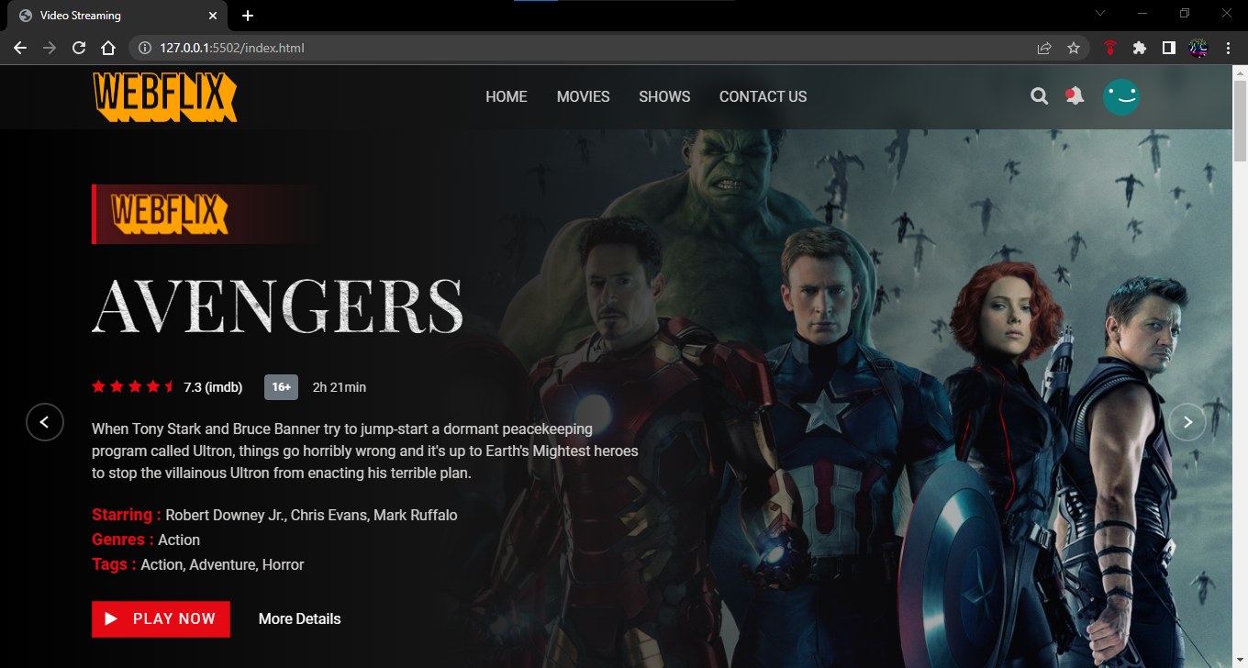

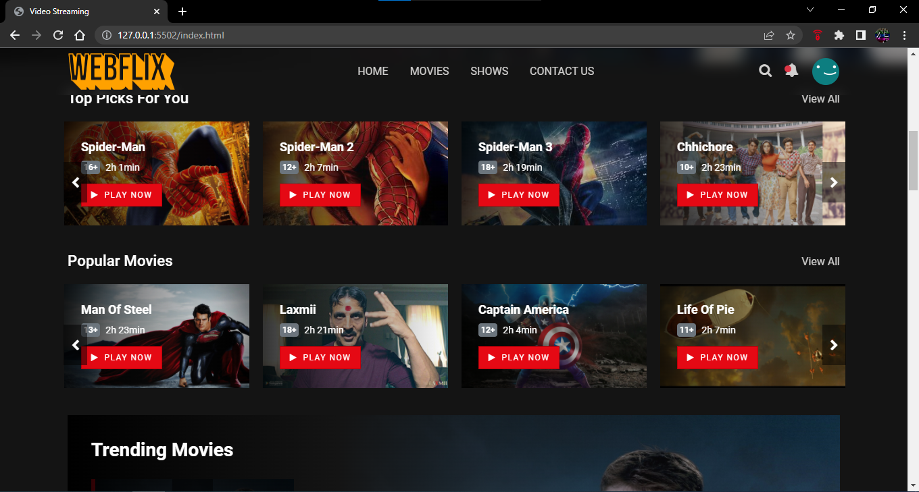

*Slider Section*

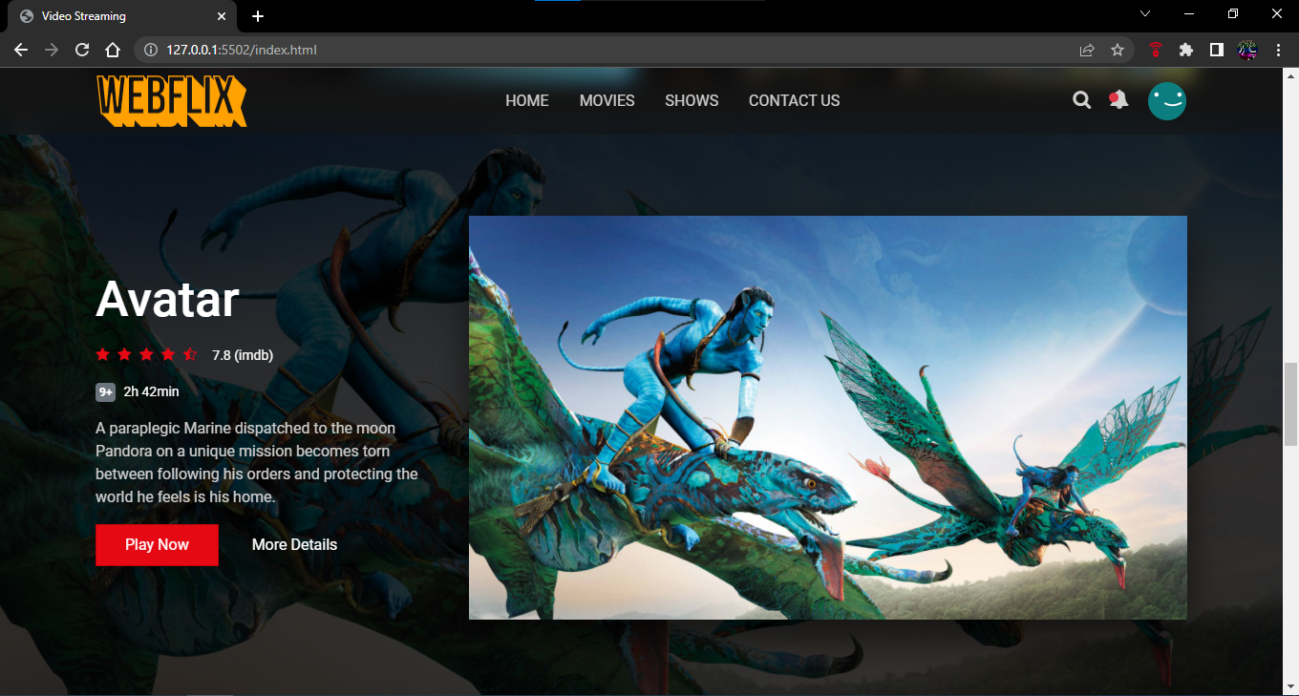

*Movies Section*

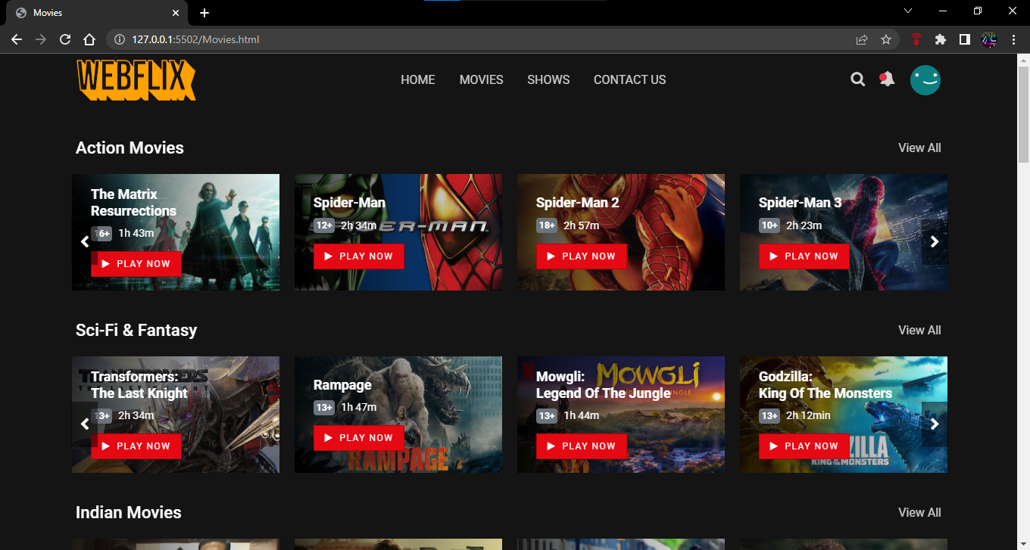

*TV Show Section*

